

**BALAJI SERVICES**

  **ONLINE LEAK SEALING MATERIAL SUPPLIERS.**

Add.: G-25/03, Shree Ganesh C.H.S.; Sector-9, Gharonda,

Ghansoli, Navi, Mumbai -400 701.

**BS  Mobile: 0-9820027556 / 9820027546**  
              **Email:** spujari79@gmail.com

*We would like to bring it to your kind notice that we are a trust worthy supplier of Online leak sealing materials such as Teflon Compounds, Fibre Compounds, Rubber Compounds, adapters and various other Online leak sealing tools and equipments at reasonable rates since several years. Our clients are scattered all over India in states like Karnataka, Tamil Nadu, Gujarat, U.P., M.P. ,Delhi, Orissa and our overseas clients at Iran and so on.*

|  |  |  |
| --- | --- | --- |
| NAME OF THE COMPOUND | MAXIMUM TEMPERATURE | LINE CONTENT |
| ½ A | UPTO 250* | Water, Steam, BFW |
| 2C | UPTO 200* | Dowtherm line, gas line, hydrocarbons. |
| 5A | UPTO 300* | Steam |
| 6B | UPTO 300* | Acids of high temp. |
| 7A | UPTO 500* | Steam, Oil. |
| CO28 | UPTO 450* -500* | LPG and all types of gas line. |
| G1 | UPTO 250*-350* | Steam, BFW. |
| G2 | UPTO 350* | Steam, BFW. |
| G3 | UPTO 450* | Lpg, Gas line of all types. |
| G4 | UPTO 450* | LPG gas. |
| GT5 |  | Acids of all types. |

# We also assure to provide you the materials at reasonable rates with unbeatable quality.

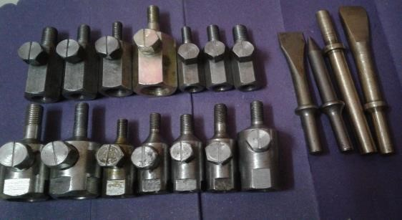 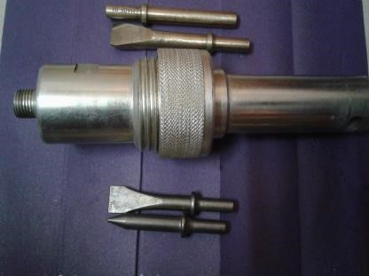

**Brass M/S Chissel Injection Unit**

**Adopters – EN-8, EN-24,**

**Brass Chissel ( For Gas Cauking) Made in Japan**

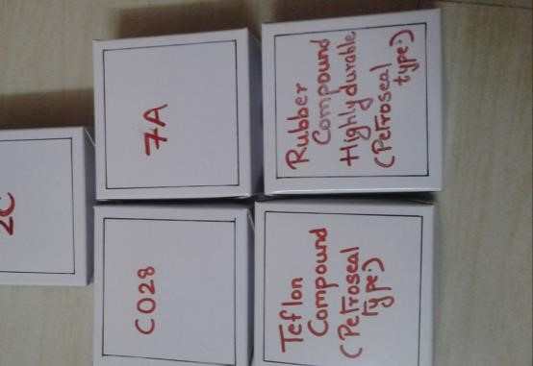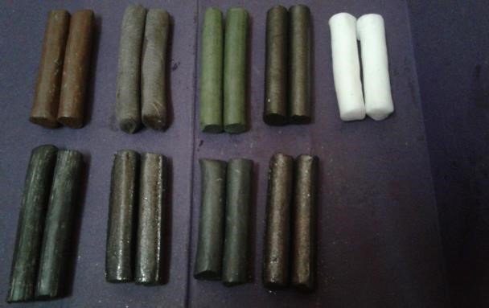

**This type of Boxes**

**All Type of**

**Compoun**

**d**

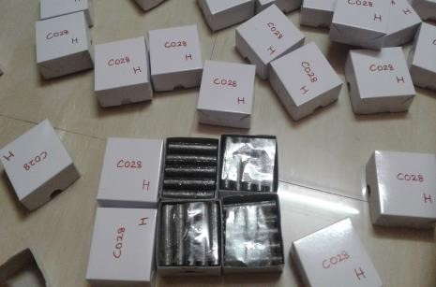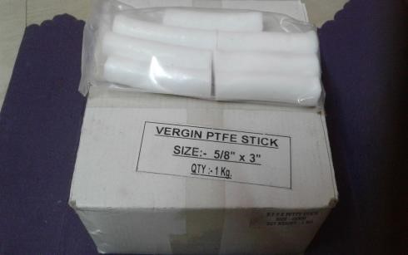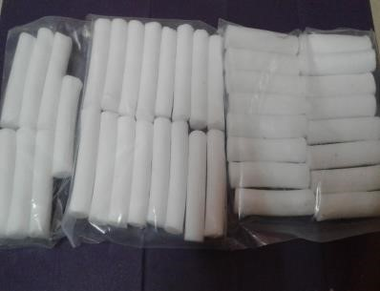

**Compound Boxes**

**Teflon Box**

**–**

**1**

**kg**

**Type of Compoun**

**d**



**This type of Boxes**

**All Type of**

**Compoun**

**d**



**Compound Boxes**

**Teflon Box**

**–**

**1**

**kg**

**Type of Compoun**

**d**

